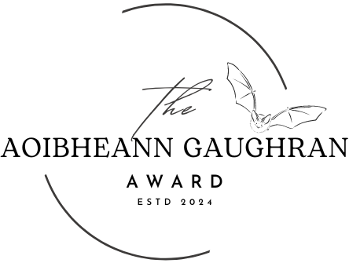

Sponsored by Bat Conservation Ireland

**Nomination Form**

|  |  |
| --- | --- |
| **Name of Nominator:** |  |
| **Contact Details of Nominator (e-mail/phone No):** |  |
| **Nominated Person:** |  |
| **Contact Details of Nominated Person (e-mail/phone No):** |  |
| **Is the nominee of good character to your knowledge:** |  |
| **Length of time (Approx) the nominee has worked/volunteered in the area of bat conservation:** |  |
| **Reason for Nomination**  **(300-350 words):**  *Please include as much detail as you can, including reasons for nomination, any projects that the nominee has been involved with that involve bat conservation and any work to date they have carried out that have helped promote and/or conserve Irish bats* |  |
| **Collaborations:** | *Please list an collaborations/projects that required working with others that the nominee has been involved in, which highlights their ability to work/volunteer across different sectors to help bat conservation* |
| **Please list examples where the nominee has show real leadership in their work/voluntary efforts to conserve Irish bats** |  |
| **Any other relevant information you would like to include to support this nomination** |  |
| **Signed:** |  |
| **Date:** |  |

Entries should be emailed to: [admin@batconservationireland.org](mailto:admin@batconservationireland.org)